Experiment No. 7

Aim : To implement SVM for EX-OR gate with 2 class (Class 0 and Class 1) & Fisher iris dataset (3D with 2 flowers)
Theory :
fitcsvm(): trains or cross-validates a support vector machine (SVM) model for one-class and two-class (binary) classification on a low-dimensional or moderate-dimensional predictor data set.
fitcsvm supports mapping the predictor data using kernel functions, and supports sequential minimal optimization (SMO), iterative single data algorithm (ISDA), or L1 soft-margin minimization via quadratic programming for objective-function minimization.
Support Vector Machine (SVM) is a supervised classification model that helps in providing the most symmetrical decision boundary possible
- For EX-OR :
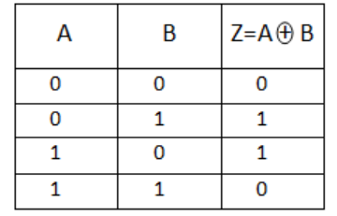
- For Fisher Iris – We have to Load Fisher's iris data set and remove the sepal lengths and widths and all observed setosa irises.
Dataset used : Fisher Iris dataset (in-built)

Code 1 (EX-OR) :
%%Experiment No. 6
% Arjun Thakur ENTC A
% 17070123023 (G1)
X=[0 0; 0 1; 1 0; 1 1];
Y=[0; 1; 1; 0];
Mdl=fitcsvm(X,Y,'KernelFunction','rbf');
sv=Mdl.SupportVectors;
figure
gscatter(X(:,1),X(:,2),Y);
hold on
plot(sv(:,1),sv(:,2),'ko','MarkerSize',10);
hold off

Output :

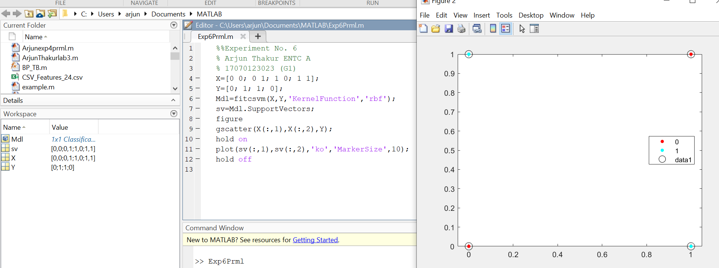

Code 2 (Fisher Iris Dataset) :
load fisheriris
inds = ~strcmp(species,'setosa');
X = meas(inds,3:4);
y = species(inds);
SVMModel = fitcsvm(X,y)
classOrder = SVMModel.ClassNames
sv = SVMModel.SupportVectors;

figure
gscatter(X(:,1),X(:,2),y)
hold on
plot(sv(:,1),sv(:,2),'ko','MarkerSize',10)
legend('versicolor','virginica','Support Vector')
hold off

Output & Command Window :
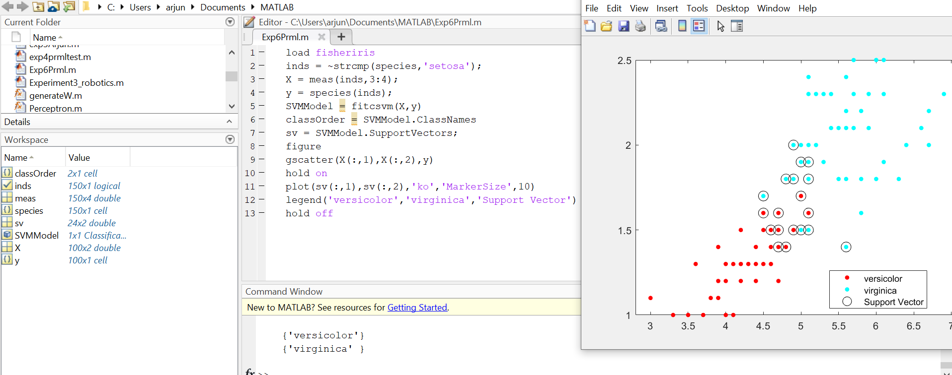

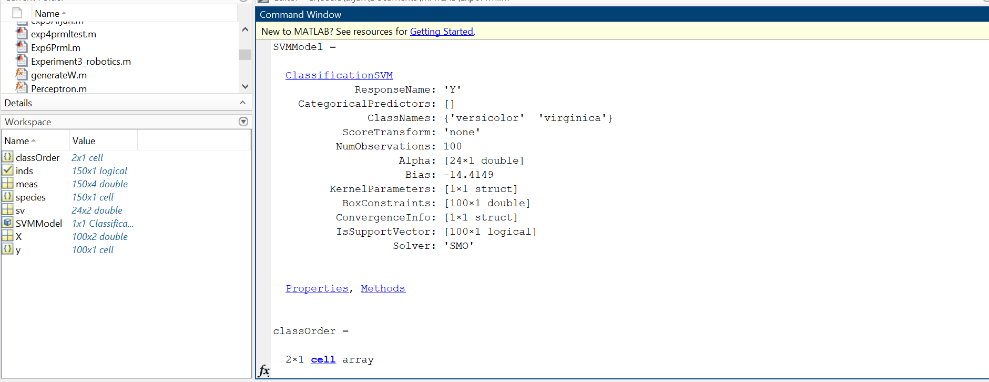

Conclusion :

Thus I have learned how to perform SVM using EX-OR and Fisher iris dataset by picking up appropriate SVM function, Defining input, Kernel and ploting the data successfully on MATLAB. The support vectors are observations that occur on or beyond their estimated class boundaries. Thus, we can adjust the boundaries (and, therefore, the number of support vectors) by setting a box constraint during training using the 'BoxConstraint' name-value pair argument.

